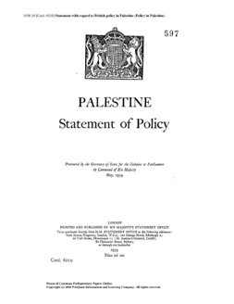

**6b. The White Paper of 1939**

Key points:

* Jewish immigration: restricted to 75,000 over 5 years
* Land purchase: Zionists could only buy Palestinian land in 5% of the country
* The future of Palestine-Israel: a Jewish national home would be established within an independent Palestinian state within 10 years

**6b. The White Paper of 1939**

Key points:

* Jewish immigration: restricted to 75,000 over 5 years
* Land purchase: Zionists could only buy Palestinian land in 5% of the country
* The future of Palestine-Israel: a Jewish national home would be established within an independent Palestinian state within 10 years

**6b. The White Paper of 1939**

Key points:

* Jewish immigration: restricted to 75,000 over 5 years
* Land purchase: Zionists could only buy Palestinian land in 5% of the country
* The future of Palestine-Israel: a Jewish national home would be established within an independent Palestinian state within 10 years

**6b. The White Paper of 1939**

Key points:

* Jewish immigration: restricted to 75,000 over 5 years
* Land purchase: Zionists could only buy Palestinian land in 5% of the country
* The future of Palestine-Israel: a Jewish national home would be established within an independent Palestinian state within 10 years